OptiX OSN 6800 (HUAWEI TECHNOLOGIES (http://www.huawei.com/pe/), Eastern Independent Telecommunications Ltd. (http://www.eit.ca/index.php/optical-solutions/huawei/osn-6800a))

Product Overview

The OptiX OSN 6800 is intended for provincial backbones, metropolitan core layers, and metropolitan convergence layers of networks in the broadcasting and TV industry and power industry. The OptiX OSN uses a new architecture and therefore supports dynamic service grooming at the optical layer and flexible service grooming at the electrical layer. In addition, the OptiX OSN 6800 features high integration and reliability and supports multi-service transmission.

In addition to service convergence, transmission, and cross-connection, the OptiX OSN 6800 supports Layer 3 dynamic traffic diversion (optical cross-connection, ODU cross-connection, and integrated LAN switch). By using advanced technologies such as reconfigurable optical add/drop multiplexers (ROADMs), wavelength tunable optical modules, ASON/GMPLS features, 40G transmissions, and LAN switches, the OptiX OSN 6800 is more flexible in architecture and suitable for broadband IP transport.

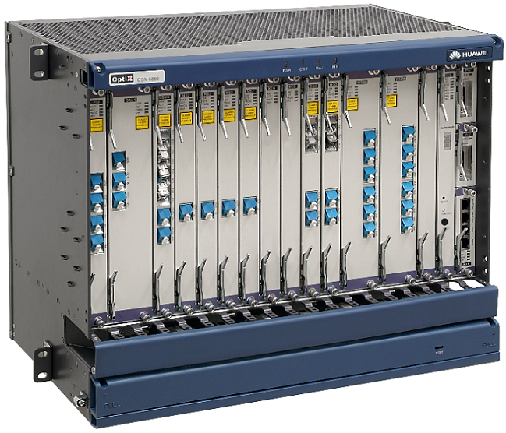

Product Features:

Good broadband transport performance: Though traditional WDM systems provide large-capacity transmission, they have poor flexibility, OAM functions, and end-to-end configuration functions that make it difficult for these types of systems to cope with the rapid increases in broadband services.

Based on the OTN/ASON transport plane, the OptiX OSN 6800 supports end-to-end service grooming at both the optical and electrical layers. Integrating the ASON/GMPLS features, the OptiX OSN 6800 is able to better fulfill the requirements for All-IP network development.

Flexible service grooming: Empowered by the OTN cross-connections of optical-layer wavelengths and electrical-layer subwavelengths, the OptiX OSN 6800 provides flexible grooming of large granular services between different sites, providing bandwidth with the click of a button.

Dynamic optical layer
With the dynamic optical layer, the OptiX OSN 6800 supports multi-dimensional cross-connection of wavelengths and transmits services quickly over wavelengths, reducing the costs on O-E-O conversion.

Flexible electrical layer
With the flexible electrical layer, the OptiX OSN 6800 supports add/drop multiplexing (ADM) or multiple add/drop multiplexing (MADM), which enables automatic end-to-end creation, monitoring, fault diagnosis, protection configuration, and traffic policing of wavelengths.

Layer 2 data processing
By integrating the LAN switch functions, the OptiX OSN 6800 supports convergence of locally added Ethernet services, including convergence of nxGE services into mxGE (m<n), and convergence of nxGE services into 10GE services, effectively improving the bandwidth utilization.

Numerous protection mechanisms: In addition to all traditional WDM equipment's protection mechanisms, the OptiX OSN 6800 provides electrical-layer protection (for example, SW-SNCP and MS-SPRing) and mesh protection. Compared with traditional channel-level 1+1 protection, the electrical-layer protection and mesh protection are more reliable, not only capable of withstanding multi-point faults but also enabling carrier-class switching time (less than 50 ms).

Easy to manage: The OptiX OSN 6800 is developed based on the OTN/ASON platform and provides an array of overheads. With these overheads, the OptiX OSN 6800 supports SDH-like network management and supervision and service-level management like end-to-end bandwidth management, convergence, and detection that facilitate quick troubleshooting and thereby improve network maintenance efficiency.

Intelligent optical network: A traditional WDM network needs to be configured by maintenance engineers using a network management system (NMS). When there is a demand for establishing or deleting a service from the network, maintenance engineers must manually create or remove the service connections on site, leading to low maintenance efficiency.

This problem can be resolved by changing static WDM networks into dynamic and flexible automatically switched optical networks (ASONs) because ASONs can automatically establish and delete service connections, thereby quickly deploying services.

ASONs have the following functions:

Auto-discovery of network topologies and devices (for example, nodes and fibers)
Automatic creation of end-to-end optical paths
Optical- or electrical-layer SLA
Easy network design/planning/simulation system

